ASSIGNMENT NO.: 2

## What do you mean by a project? What are the triple constraints?

**Ans.** To study project management it is necessary to first understand the concept of a project.

- A project is defined as an undertaking of a non-routine, non-repetitive nature having prescribed objectives in terms of scope, time, quality and cost.

- A project is undertaken to create something new, unique, or to enhance an existing product, service, or system.

- A project is a temporary endeavor undertaken to create a unique product, service, or result.

- A project is an endeavor to accomplish specific objectives through a unique set of interrelated tasks and effective utilization of resources.

- IT projects involve hardware, software and networks to create product, service, or result. A few examples of IT projects are;

- A new feature is added to an existing software application.

- A new system is developed to increase sales force productivity, improve customer relationship management and enhance supply chain management.

- A firm decides to implement an integrated ERP project to consolidate its information systems.

- Replacing the company's manual timekeeping system with a web-based system within a particular time frame.

**Triple constraint:**

All projects are carried out under certain constraints – traditionally, they are cost, time and scope. These three factors (commonly called 'the triple constraint') are represented as a triangle (see Figure 1). Each constraint forms the vertices, with quality as the central theme:

- Projects must be delivered within cost

- Projects must be delivered on time

- Projects must meet the agreed scope – no more, no less

- Projects must also meet customer quality requirements

- Project Management Triple Constraint Diagram

**The Triple Constraint**

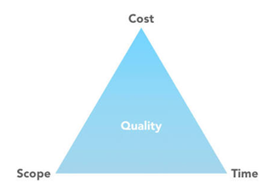

More recently, the triangle has given way to a project management diamond: cost, time, scope, and quality are now the four vertices, with customer expectations as a central theme (see Figure 2). No two customer expectations are the same, so you must ask specific questions about the customer's expectations:

**Project Management Diamond Diagram**

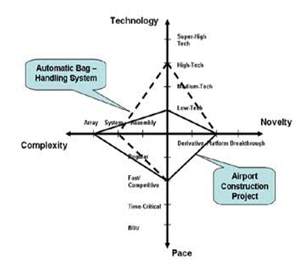

**1.** **Cost:** All projects have a finite budget; the customer is willing to spend a certain amount of money for delivery of a new product or service. If you reduce the project's cost, you will either have to reduce its scope or increase its time.

**2. Time (Schedule):** As the saying goes, 'time is money', a commodity that slips away too easily. Projects have a deadline date for delivery. When you reduce the project's time, you will either have to increase its cost or reduce its scope.

**3. Scope:** Many projects fail on this constraint because the scope of the project is either not fully defined or understood from the start. When you increase a project's scope, you will either have to increase its cost or time.

Once a customer asks you to complete a project, the person will state what is important; for example, the project must cost no more than £50k, be delivered by a particular date, or contain certain features.

The triple constraint is about balancing each constraint to reach a successful conclusion. As the project progresses, the project manager may find that any changes impact one or more of the constraints.

## What are the attributes/characteristics of a project?

**Ans.** A few typical project attributes are as follows:

**Purpose-** A project has a unique purpose and well-defined objectives. It begins with a rough con initial plan which is updated as more information emerges. Projects are undertaken to accomplish Something of value to the company, maybe, a system or software. The sole purpose of undertaking a project is to produce a tangible product of value to the company.

**Goal -** A goal drives e project. It is the sole motivating factor and defines each activity, task, work schedule and budget of the project. It provides direction to the team. Hence, the project goal should clearly be defined, ambiguity in defining the project goal leads to a project with no end.

**Time frame -** Since a project is a temporary endeavour it has to have a definite start and end. The time frame for achieving the project goal is estimated based on the duration of the various project activities. The completion date of the project is set accordingly. However, for projects where the completion date is fixed, such as the Y2K problem, the starting date has to be set by working backward.

**Interrelated tasks and resources -** A project is composed of interrelated tasks and utilizes resources such as people, software, hardware and other assets of the company. The primary asset for an IT project is people who cross-departmental and other boundaries to achieve this unique purpose. Most projects demand the service of people outside the organization such as consultants, Resources, however, are expensive and limited hence should be used effectively to meet project objectives. A project is unique and hence is difficult to estimate the time, budget and resources requirement. Hence, a project involves uncertainty.

**Ownership -** A project has various stakeholders but only one primary customer known as the project sponsor. The project sponsor is the "go-to" entity for funds, direction, and approvals regarding all project-related matters. For the project manager the project sponsor is the owner of the project.

**Risks and Assumptions -** Every project has a certain risk element, the more complex and bigger the project greater is the risk. Risk is directly proportional to the size and complexity of the project. Risks can emanate from sources both internal and external to the project team. Internal risks could be the resignation of a key project member, while external risks could arise from vendors and suppliers of key hardware and software. Assumptions are those unknown variables which are used to estimate key facets of the project. Therefore, the project manager has to identify all the risks and assumptions that could impact the project.

## Explain the project life cycle and its relation with SDLC.

**Ans.** The project life cycle (PLC) is a collection of logical stages or phases that maps the life of a project from its beginning to its end to define, build, and deliver the product of a project—that is, the information system. Each phase should provide one or more deliverables. A deliverable is a tangible and verifiable product of work. Deliverables at the end of each phase also provide tangible benefits throughout the project and serve to define the work and resources needed for each phase.

Projects should be broken up into phases to make the project more manageable and to reduce risk. Phase exits, stage gates, or kill points are the phase-end review of key deliverables that allow the organization to evaluate the project's performance and to take immediate action to correct any errors or problems. Although the deliverables at the end of a stage or phase usually are approved before proceeding to the next stage, fast-tracking or starting the next phase before approval is obtained can sometimes reduce the project's schedule. Overlapping of phases can be risky and should only be done when the risk is deemed acceptable.

1. **Define the project goal**: Defining the project's overall goal should be the first step of the project. This goal should focus on providing business value to the organization. A well-defined goal gives the project team a clear focus and drives the other phases of the project.
2. **Plan Project:** Once the project's goal has been defined, developing the project plan is a much easier task. Some of the questions asked are:
3. What are we going to do?
4. Why/How are we going to do it?
5. Who is going to be involved?
6. How long will it take and how much will it cost?
7. What can go wrong and what can we do about it?
8. How did we estimate the schedule and budget?
9. How will we know if we are successful?

Also, the deliverables, tasks, resources, and time to complete each task must be defined for each phase of the project. This project plan defines the agreed-upon scope, schedule, and budget and is used as a tool to gauge the project's performance throughout the life cycle.

1. **Execute the project plan:**

After the project's goal and plan have been defined, it's time to put the plan into action. As work on the project progresses, scope, schedule, budget, and people must be actively managed to ensure that the project achieves its goal. The project's progress must be documented and compared to the project's baseline plan. Also, project performance must be communicated to all of the project's stakeholders. At the end of this phase, the project team implements or delivers a completed product to the organization.

1. **Close Project:**

A project should have a definite beginning and end. The closing phase of a project ensures that all of the work is completed as planned and as agreed to by the project team and the sponsor. Therefore, there should be some kind of formal acknowledgment by the sponsor that they will accept the product delivered. This closure is often capped with a final project report and presentation to the client that documents that all promised deliverables have been completed as specified.

1. **Evaluate Project:**

Evaluating whether the project met its goal can be made only after the system has been implemented. The project team should document its experiences in terms of lessons learned -those things that it would do the same and those things it would do differently on the next project, based on its current project experiences. This post mortem should be documented, stored electronically, and shared throughout the organization. Subsequently, many of these experiences can be translated into best practices and integrated into future projects. The project manager may evaluate each project team member's performance to provide feedback and as part of the organization's established merit and pay raise processes and procedures.

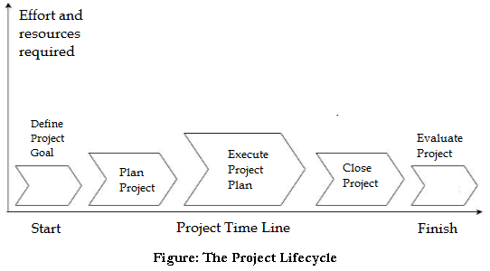

* **How PLC relates to SDLC:**

The project life cycle (PLC) focuses on the phases, processes, tools, knowledge and skills of managing a project, while the system development life cycle (SDLC) focuses on creating and implementing the project’s product – the information system. How a project team chooses to implement the SDLC will directly affect how the project is planned in terms of phases, tasks, estimates and resources assigned. The SDLC is part of the PLC because many of the activities for developing the information system occur during the execution phase. The last two stages of the PLC, closing and evaluating the project, occur after the implementation of the information system. The integration of project management and system development activities is one important component that distinguishes IT projects from other types of projects.

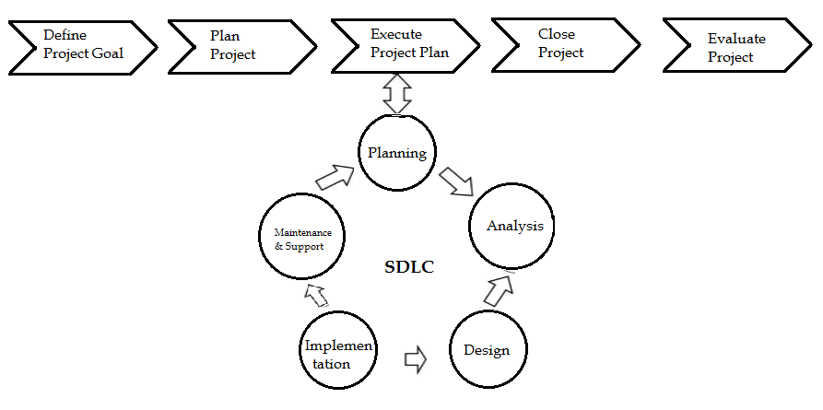

## 4. Describe the PMBOK.

**Ans.** The Project Management Body of Knowledge Guide (PMBOK Guide prepared by the Project Management Institute, UBA, includes aa of project management.

The purpose of the PMBOK Guide is to identify the "good practices" that apply to month projects, most of the time and that there is widespread consensus about their value and usefulness. However, "good practices" does not mean that knowledge should be applied uniformly to all the projects; the project management team should be responsible for determining what is appropriate for their project.

The PMBOK Guide is used by various Project Management Institute as a foundation for their professional development program. However, this guide only addresses project management practices that are generally recognized as "good practices", there are other external standards on organization project management that are also recognized as "good practices" but are not addressed by the guide.

Hence, to develop an overall view of project management external additional information should also be refereed.

The PMBOK Guide proves useful too -

1. Senior Executives
2. Project managers
3. Functional manager
4. Project team manager
5. Stakeholder
6. Trainers
7. Consultant
8. Researchers

**PMBOK Knowledge Areas**

The PMBOK defines nine knowledge areas for understanding project management and is as follows:

* Project Integration Management Knowledge Area – This area includes the processes and activities needed to identify, define, combine, unify and coordinate the various processes and activities within the project management process groups. Integration activities are crucial to project completion. Integration management focuses on coordinating the project plans development, execution, and control.
* Project Scope Management Knowledge Area – This area includes all the processes that are needed to ensure that project scope includes all the work required to be completed by the team, and only the work required to complete the work successfully. Scope management assures that project work expected from the team is defined accurately and completely and that the work is undertaken and completed as planned. Also, it is essential for Scope management to include proper scope management procedures.
* Project Time Management Knowledge Area – This knowledge area includes the processes required to develop, monitor, and manage the project schedule such that the timely completion of the project is accomplished. Time management identifies project phases and activities and then estimates and sequences them. The assignment of resources to ensure the timely completion of the project while ensuring that the project scope and objectives are met is also included in this area.
* Project Cost Management Knowledge Area – This includes the processes involved in planning, estimating, budgeting and controlling coats so that the project can be completed within the approved Budget
* Project Quality Management Knowledge Area – Includes all the activities of the organization that determines quality policy, objectives and responsibilities so that the project will satisfy or exceed the needs of the stakeholders for whom the project had been undertaken.
* Project Human Resource Management Knowledge Area – This area focuses on managing the most important resource on a project. It includes the processes that organize and manage the project team
* Project Communication Management Knowledge Area – This area focuses on developing processes that are required to ensure timely, accurate, and appropriate generation, collection, distribution, storage, retrieval, and disposition of project information.
* Project Risk Management Knowledge Area – this includes all the processes associated with risk management planning, identification, response and monitoring on a project:
* Project Procurement Management Knowledge Area – All resources i.e. people, hardware or software, needed for the project may not be available within the organization and it may need to procure some from outside sources. The procurement management area includes the processes to purchase or acquire these products or services to perform the work.

The concepts associated with information systems and software engineering when integrated with the nine knowledge areas outlined in PMBOK provide the foundation for IT project management. Since the PMBOK guideline are generic to any project, the integration of information systems management and software engineering with PMBOK concepts helps distinguish IT projects from other projects such as construction and engineering

## 5. What are the phases of ITPM?

Ans. A methodology provides a strategic-level plan for managing and controlling IT projects.

The methodology is a template for initiating, planning, and developing an information system. It is the product and not the process of managing the project that makes the information system different.

The ITPM recommends the following phases, deliverables, tools and knowledge areas for supporting an IT project.

The following are the phases in ITPM:

1. **Phase 1: Conceptualize and Initialize**

The first stage of ITPM involves defining the goals of the project. The project's goal aids in defining the project's scope and guides decisions throughout the project life cycle. It is also used at the end to determine the success of the project. Alternatives to meet the goal must be specified and cost and benefits, risk and feasibility of these alternatives are analyzed. Based on this analysis, one alternative is recommended and the goal and analysis are summarized in a deliverable called the business case. Senior management then takes the decision whether to fund the project or not based on the business case.

1. **Phase 2: Develop the Project Charter and Detailed Project Plan**

The project charter is a key deliverable in the second phase of ITPM. It defines how the project will be organized and how the project alternative that was recommended and approved for funding will be implemented. The project charter defines the project's objectives in terms of scope, schedule, budget, and quality standards and gives authority to a project manager to begin carrying out the processes and tasks associated with the systems development life cycle (SDLC). The project plan provides all the tactical details concerning who will carry out the project work and when. Sometimes the project charter and plan may be combined with a business case but this is not recommended.

1. **Phase 3: Execute and Control the Project**

The third phase of ITPM focuses on carrying out the project plan to deliver the IT product and managing the project’s processes to achieve the goal. It is during this phase that the project team uses a particular approach and set of systems analysis and design tools for implementing the systems development life cycle (SDLC). The project manager must ensure that the environment and infrastructure to support the people includes items like – technical infrastructure for development, acquisition of people with proper skills, development method, and tools, a proper work environment, a detailed risk plan, quality management plan, change management plan, testing plan, implementation plan, etc.

1. **Phase 4: Close Project**

After the information system has been developed, tested, and installed, a formal acceptance should transfer control from the project team to the client or project sponsor. The project team must prepare a final project report and presentation to document and verify that all project deliverables have been completed as given in the project scope. This installs confidence in the project sponsor. The final cost of the project can be determined at this time. The project manager and team must follow a set of processes to formally close the project by doing such things as closing all project accounts, archiving all project documents and files, and releasing project resources.

1. **Phase 5: Evaluate Project Success**

The final phase of the methodology focuses on evaluating four areas.

1. A final project review should be conducted by the project manager and the team assessing what went well and what could have been done better on the project. The lessons learned should be documented and shared with others. Best practices are identified and institutionalized in the organization.
2. The second review is between the project manager and the individual team members. Although this performance review may be structured in terms of the organization's performance and merit review policies and procedures, each member of the team must receive honest and useful feedback concerning his or her performance on the project.
3. An outside party must review the project manager and team based on – whether the project met its scope, whether the team delivered on its promises, whether the project manager and team followed due processes and other factors.
4. The project must be evaluated to see if the project provided value to the organization. In general, the value of an IT project brings to the organization may not be discernible immediately after the project is implemented. Therefore, it may be weeks or even months before that value is known.

Methodologies provide the team with a game plan for implementing the project and product life cycles. Additionally, a methodology provides a common language between the team, manager, and sponsor. A good methodology should be flexible and adapt to the needs of the project organization over time.

## 6. Write steps for preparing Business Case.

**Ans.** Steps in developing the business case are as follows:

**Step 1: Forming the team** – Developing the business case should not be a single man’s responsibility. On the other hand, a team comprising of stakeholders, managers, users and IT specialists should be formed. The team so formed should bring in all the requisite knowledge, experience, information and expertise required to develop the business case. Of the team, the stakeholders are the people who are going to be affected by the project and hence their point of view needs to be presented in the business case document. Business managers bring in a higher level of perspective which is so essential for the business case. The users are the ones who understand the requirements that the project has to fulfill. While the IT specialists understand the risks and benefits associated with IT and should present their perspective in the business case.

According to Schmidt, there are several advantages of having a team develop the business case:

* **Credibility** - As a team is made up of individuals from various organizational areas, they possess expertise, knowledge and experience that may not be readily available outside the realms of their operations. A team also provides different perspectives on the project and provides inputs that an individual developer may tend to overlook.
* **Alignment with organizational goals** - The managers in the core team can align the business case with the long-term strategic goals of the organization. Aligning the project with the strategic goals of the organization further strengthens the business case. The business case should also highlight how the successful completion of the project will help achieve the overall goals and objectives of the organization.
* **Access to real costs -** The team members selected should have specific expertise and should be privy to information that will assist in building a realistic estimate of the costs.

The other advantage of forming a team from various areas of the organization is that it enables the project manager to manage resistance during project implementation.

**Step II: Developing Measurable Organizational Value (MOV)** - Measurable organizational value (MOV) is the IT project's overall goal and its measure of success. For any project the MOV should align with the organization's overall mission, objectives and goals. The term Measurable Organizational Value was coined by Jack Marchewka as an alternative to the more popular return on investment (ROI). According to Jack Marchewka the projects MOV should be:

* Measurable
* Provide value to the organization
* Agreed upon by all the core team members.
* Verifiable at the end of the project.
* Guide the project throughout its lifecycle.
* Align with the organization's strategy and goals.

A clear MOV will enable the team to know where the project should go, it will be like the road that the whole project lifecycle should take. In case the project deviates from its path, the relevant decisions and adjustments will be based on the MOV which can be vital in achieving the overall goal.

**Steps in developing the MOV**

**(i) Identifying the desired area of impact –** The desired area of impact expected from the IT project is the primary reason for undertaking the project. To identify the desired area of impact the project manager should find out from the project sponsor how the idea of the project came about. Although, the answers could be vague it would provide the project manager with some elementary background as to how decisions are made in the organization.

**(ii) Identifying the desired value of the project** - The value that a project brings to an organization could be in terms of doing something faster, better, cheaper, or on increasing the market share. The project manager should identify and highlight what the project could potentially deliver to the organization.

**(iii) Developing an appropriate metric -** Once the desired value of the project has been identified it is time to quantify the value that would be delivered. So for example a proposed business information system would enable a company to process customer orders faster, the management would be better off in learning the reduced customer order cycle time. Therefore, the value should be quantified and expressed in terms of metrics i.e. in terms of time, money, percentage or a specific value.

**(iv) Setting a time frame for achieving the MOV –** The time frame for achieving the MOV should also be mentioned. Some MOV’s are immediately achievable on the completion of the project, for example the reduction in customer order cycle time, however, some like increase in market share may take time.

**(v) Verifying with stakeholders –** Getting the metric value and time frame verified and approved from the stakeholders adds value to claims made in the business case.

**(vi) Summarize the MOV in a clear and concise statement -** The MOV should be mentioned in a clear and concise statement.

**Step III: Identifying Alternatives –** All the alternative solutions to the problem or opportunity need to Be delved upon in the business case. These alternatives should also enable the company to achieve the desired MOV. The alternative of maintaining status quo ie. Not doing anything and continuing with the present situation could not be a solution that needs to be looked into However, the business case should put forth compelling reasons to bring about change and the cost that would be incurred in continuing with the existing process, systems or product. The cost incurred could be in terms of downtime, maintenance cost and systems failure.

**Step IV: Defining Feasibility and Assess Risk –** The feasibility and risk associated with each Alternative solution should be analyzed. Feasibility is the probability of successfully implementing an alternative while risk focuses on what can go wrong and what must go right. Feasibility and risk analysis will enable the project manager to identify alternatives that are not worth pursuing. Feasibility is viewed in terms of economic feasibility, technical feasibility and organizational feasibility. Risk analysis focuses on its identification, assessment, and Response.

**Step V: Defining Total Cost of Ownership –** The total cost of ownership of the application needs to be accounted for before any decision on implementing it is to be taken. The total cost of ownership is over and above the cost of purchasing or developing the application and as such includes the cost of purchasing/developing, training, maintaining and supporting the application over its entire lifetime. Thus, the total cost of ownership calculation is complex and hence the project manager has to authenticate his calculation with data sources, assumptions and methods for arriving at the Cost.

**STEP VI: Defining Total Benefits of Ownership** - The total benefits of ownership include direct and indirect benefits associated with each alternative. Benefits could be in terms of increased efficiency, improved productivity, improved customer service, improved accuracy, and efficiency, or improved decision making. However, not all benefits all easy to identify and quantify. Every alternative has certain tangible and intangible benefits. Tangible benefits are easy to identify and quantify as they lead to cost savings. On the other hand, though intangible benefits are identifiable they are difficult to quantify. The project manager should try and quantify intangible benefits by linking them to tangible benefits.

**Step VII: Analysing alternatives -** Once costs and benefits have been identified it is time to compare all the alternatives and arrive at one that best meets the requirement of the organization. Financial models such as ROI, Payback and Net Present Value and Scoring Models are used to analyze the alternatives.

**Step VIII: Recommend Solution -** After analyzing each alternative the one that best suits the company should be recommended for approval.